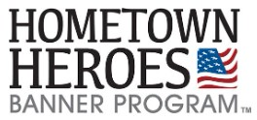
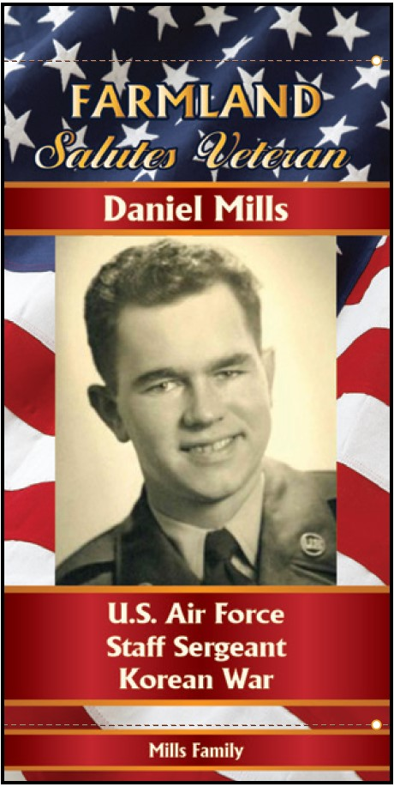
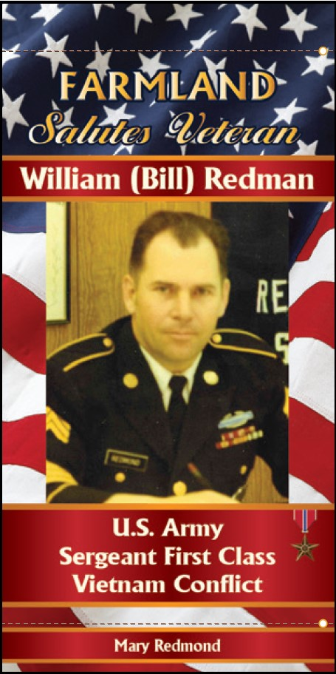
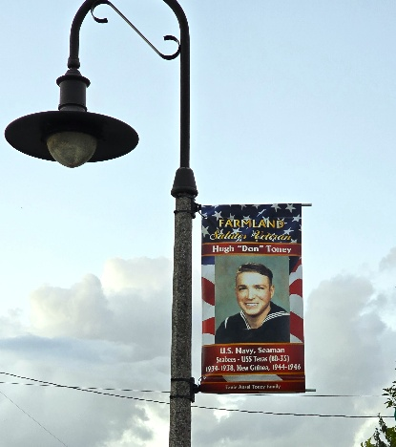

The Town of Farmland would like to celebrate our Hometown Heros by Honoring our Military Service Members!
The Town of Farmland, Indiana is launching the 3rd round of the Hometown Heroes Banner Program as a living tribute for our community to honor our past and present members of the Armed Forces.
The banners are made from heavy weight commercial grade block out vinyl which is extremely durable and holds up very well. Each banner is 24” x 48” and will mount to the town owned light poles on Main Street. The banners are printed on both sides. You can elect to include whatever information you choose for each Veteran, and the company will try to accommodate the family and include what they can based on the banner size. Remember that “Less is More” and it’s typically best to stick with Name, Rank, Branch of Service, and Era of Service. The only medals provided are the Purple Heart, Silver Star, and the Bronze Star.
Each banner is sponsored by the family or friend of a veteran. The cost of each banner is $104.95, and the Town of Farmland will purchase the mounting brackets for each banner. Approximately 2 weeks after the information is turned into the company, the company will send layout proof of all the banners. After all banner layouts are approved, the company will start production.
Please call the Farmland City Building if you have any questions 765-468-6701. We need to have an order for 5 banners to place an order. Please provide a jpeg or I will need to scan the picture you wish to use.

Honoree Profile
Please fill this out and bring it and $104.95 for each banner to the Farmland City Building.
Rank: _______________________________________________
First Name: __________________________________________ PICTURE
Last Name: __________________________________________
Branch of Service: ____________________________________
Era: _______________________________________________________________________________
- Civil War (1861 – 1865)
- Spanish American War (April 1898 – December 1898)
- WWI (April 6, 1917 – November 11, 1918)
- WWII (December 7, 1941 – September 2, 1945)
- Korean War (June 25, 1950 – July 27, 1953)
- Vietnam Conflict (November 1, 1955 – April 30, 1975)
- Cold War (September 2, 1945 – December 26, 1991)
- Persian Gulf War (August 2, 1990 – February 28, 1991) (Aug 2, 1990 – Jan 17, 1991, Operation Desert Shield / Jan 17, 1991 – Feb 28, 1991, Operation Desert Storm)
- Global War on Terror (September 11, 2001 – August 2021)

Sponsor: _________________________________________ Phone #: ________________________
Email: ____________________________________________
Status (KIA / POW / MIA): _____________________________________________________________
Medals (Purple Heart / Silver Star / Bronze Star): _________________________________________
(We will insist on a picture of those medals as needed. If you require a different medal, you will need to supply a high-resolution photo).
Other Information: ___________________________________________________________________
Banner Price: $104.95
__Cash __Check – Check # ______________ __CC #____________________

